**DATABASE MANAGEMENT SYSTEM**

**PROGRAM 2**

**NAME: DEEPIKA P**

**USN: 1NT23CS057**

**CLASS: 4TH SEM A SEC**

**The following relations keep track of airline flight information:**

**Flights (flno: integer, from: string, to: string, distance: integer, departs: time, arrives: time, price: integer)**

**Aircraft (aid: integer, aname: string, cruisingrange: integer)**

**Certified (eid: integer, aid: integer)**

**Employees (eid: integer, ename: string, salary: integer)**

**Note that the Employees relation describes pilots and other kinds of employees as well; every pilot is certified for some aircraft, and only pilots are certified to fly.**

**For the above schema, perform the following.**

**a) Create the above tables by specifying primary keys and foreign keys.**

**b) Insert around 10 records in each of the tables.**

**c) Find the names of aircraft such that all pilots certified to operate them earn more than 80,000.**

**d) For each pilot who is certified for more than three aircraft, find the eid and the maximum cruising range of the aircraft that he (or she) is certified for.**

**e)Find the names of pilots whose salary is less than the price of the cheapest route from Los Angeles to Honolulu.**

**f) Find the second highest salary of an employee.**

**a) Create the above tables by specifying primary keys and foreign keys.**

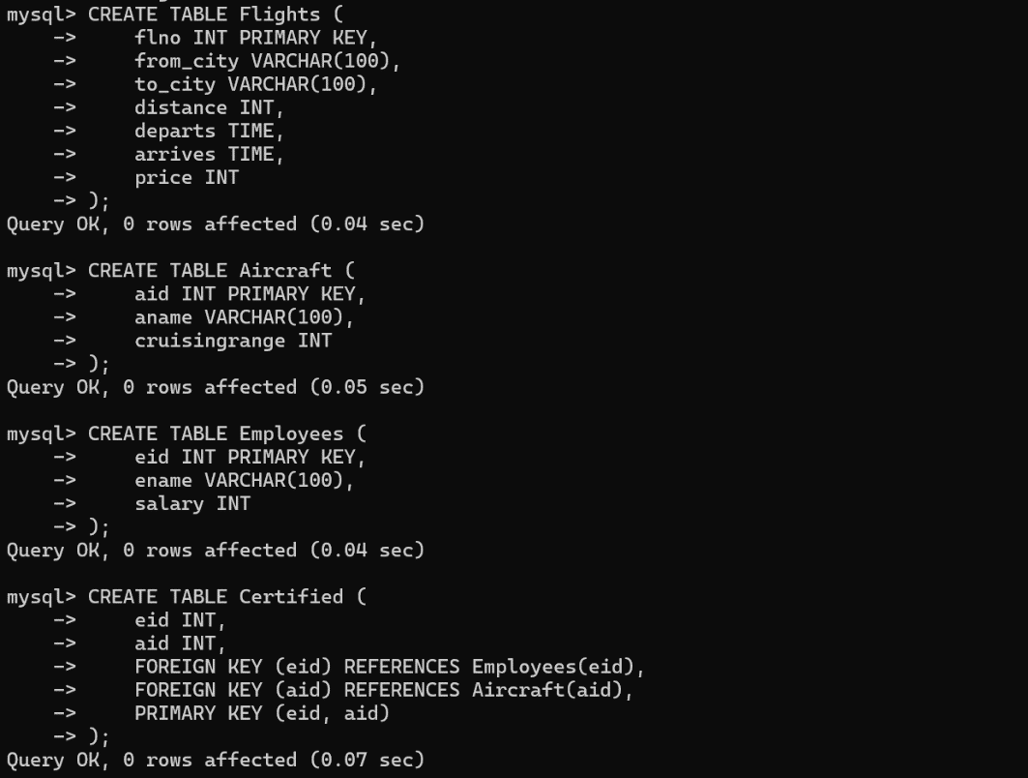

**b) Insert around 10 records in each of the tables.**

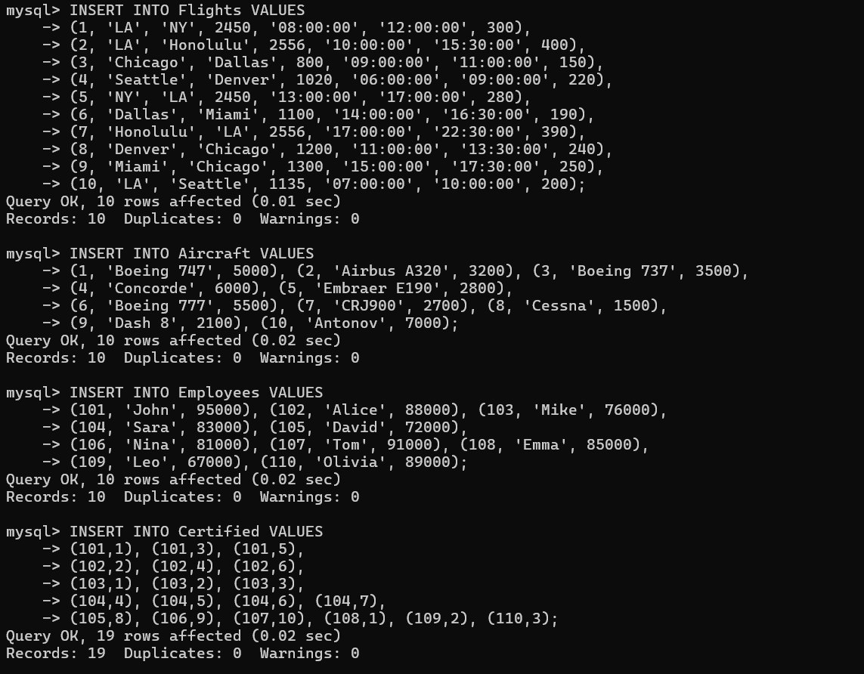

**c) Find the names of aircraft such that all pilots certified to operate them earn more than 80,000.**

**SELECT a.aname**

**FROM Aircraft a**

**JOIN Certified c ON a.aid = c.aid**

**JOIN Employees e ON c.eid = e.eid**

**GROUP BY a.aid**

**HAVING MIN(e.salary) > 80000;**

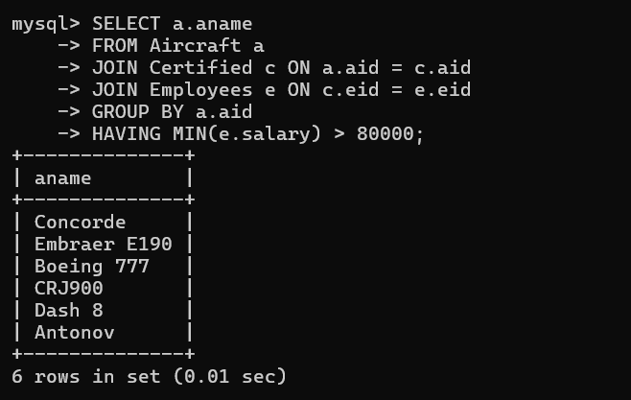

**d) For each pilot who is certified for more than three aircraft, find the eid and the maximum cruising range of the aircraft that he (or she) is certified for.**

**SELECT c.eid, MAX(a.cruisingrange) AS MaxRange**

**FROM Certified c**

**JOIN Aircraft a ON c.aid = a.aid**

**GROUP BY c.eid**

**HAVING COUNT(c.aid) > 3;**

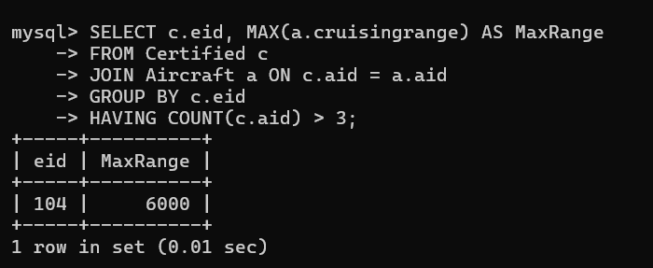

**e)Find the names of pilots whose salary is less than the price of the cheapest route from Los Angeles to Honolulu.**

**SELECT e.ename**

**FROM Employees e**

**WHERE e.salary < (**

**SELECT MIN(price)**

**FROM Flights**

**WHERE from_city = 'LA' AND to_city = 'Honolulu'**

**);**

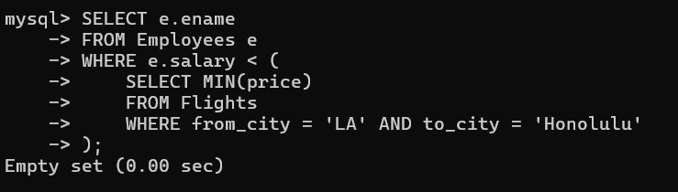

**f) Find the second highest salary of an employee.**

**SELECT MAX(salary) AS SecondHighest**

**FROM Employees**

**WHERE salary < (SELECT MAX(salary) FROM Employees);**

